**Experiment 10**

Name: Ravish Dagar

Sap-500061767

Roll No-96

* Aim- Design a UPES landscape on blender.
* Procedure-

1. Open a new blender file.
2. Add a new mesh landscape.
3. Design and alter the shape of the mountain accordingly.
4. Give the color to the mountains.
5. Select the portion of the area aside mountain and assign it as water and give blue color to it.
6. Also, select portion of the mountain top and assign it as snow and give white color to it.

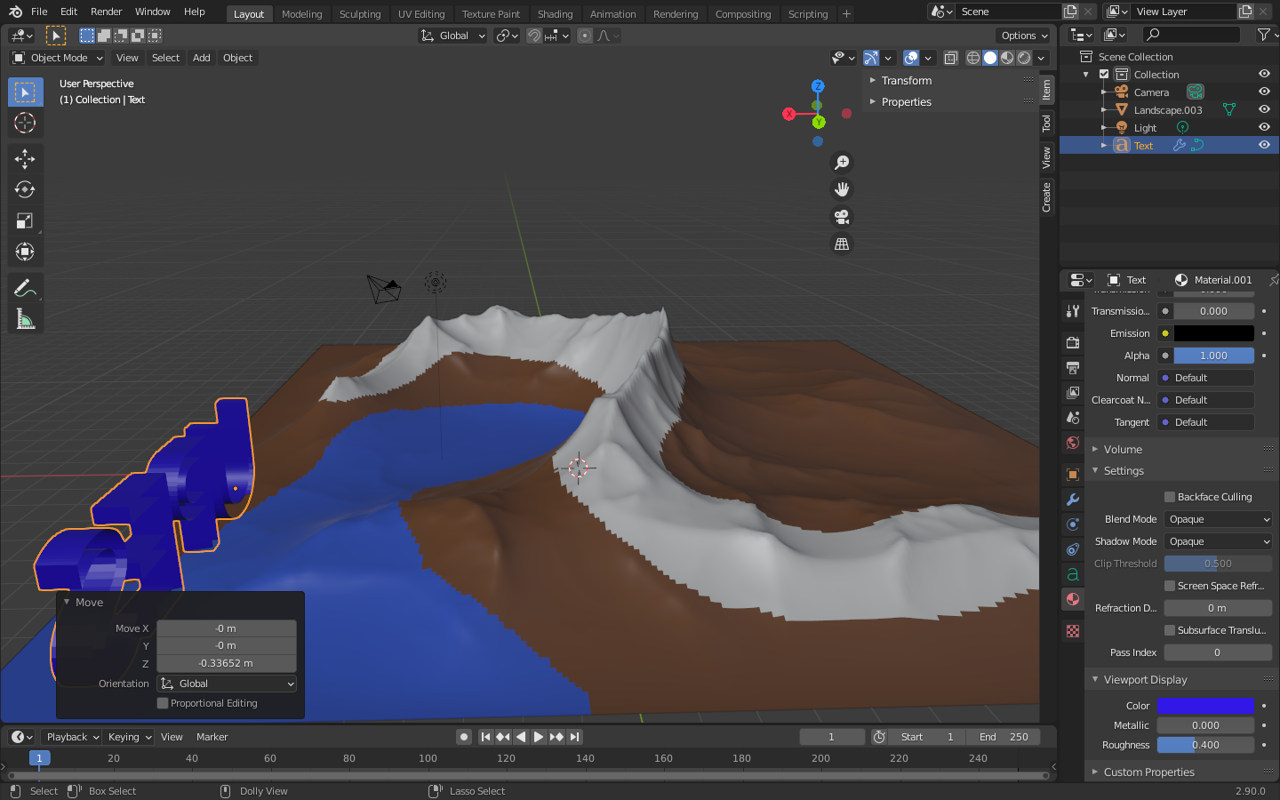

1. Now, add a text and apply a solidify modifier to it.
2. Write the name “UPES” and color and size it accordingly.
3. Join the “UPES” text to the corner of the landscape.

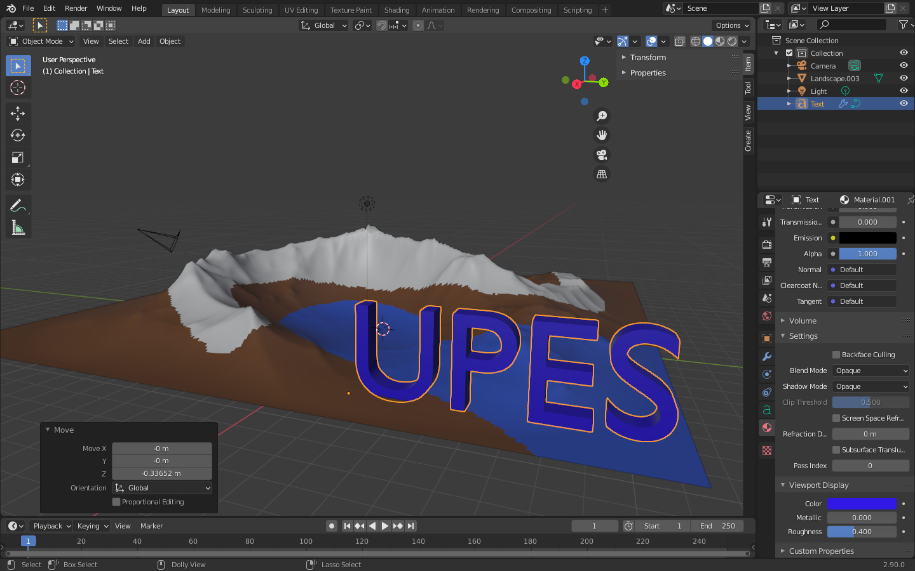

1. Hence, UPES landscape is completed.

